**EN-mig.pngLogo_JBM-PETIT.png**

**REF. 52439 MEASURING LINE/MULTIMETER TEST**

|  |  |  |  |
| --- | --- | --- | --- |
| **Name** | **Quantity** | **Picture** | **Description** |
| Variable resistance (5KΩ) | **2** | 1 | It is suitable for many components of the variable resistance type of car, like engine temperature sensor. Users can adjust resistance value if it is necessary. |
| LED examining light | **2** | 2 | The color of LED light will change when the anode & the catnode of two-color and double-way LED light change. |
| SRS replacing & testing  Device | **2** | 3 | When intending to replace the airbag, uses can connect the device to the system first, after it shows that the system is safe then install the new airbag.  **Notice: The SRS device just permits maximal electric current of 0.25A, it will be damaged when overloading.** |
| Crocodile Clip | **2** | 4 | Users can examine and measure according to demand, it can be used with Measure Stick, extension line, etc. |
| Measure Stick | **2** | 5 | Users can examine and measure according to demand, it can be used with Crocodile Clip, extension line, etc. |
| Various types of probes | **4** | 6 | Please pay attention to the touching angle when the probe is used to avoid the accident. |
| One to two form | **2** | 7 | http://www.ecpal.com/tc/pro/ec0004/ec0004_12.jpg |
| One to one form | **4** | 8 | http://www.ecpal.com/tc/pro/ec0004/ec0004_13.jpghttp://www.ecpal.com/tc/pro/ec0004/ec0004_14.jpg |
| Round Shape connector | **24** | 9 | Use based on demand |
| Flat Shape Connector | **48** | 10 | Use based on demand |

**Logo_JBM-PETIT.pngApplication guide**

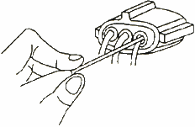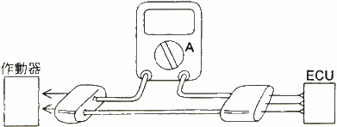  
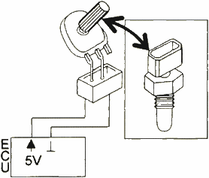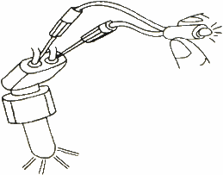

1. While measuring the component, users do not need to damage the circuit. It can be examined directly from the back of the plug-terminal to prevent the circuit from oxidation causing the larger resistance-hole.
2. It applies to the extension lines of any oscilloscope and any ammeter, prevents the trouble from connecting wires, and assists users in the fast measurement.
3. While measuring the electric current, users do not need to cut off the electric wire. The quick make wire of Universal Line Kit can be in series with the circuit loop.
4. The variable resistance can model the false signals sensing from the components in the temperature sensor and the throttle-position sensor, and transmits them to the computer. It reduces the risk of exchanging another component.
5. It is equipped with two sets of LED lights that are able to monitor control signal from Hall Effect, photoelectric signal, fuel sprayer, electromagnetic valve, electromagnetic valves of gearbox selector, etc.
6. The SRS replacing & testing device can model the statuses of airbags and retractor of safety belt, and avoid causing the accident or false diagnosis.
7. Various kinds of lines set can be applied to the plug terminal of various kinds of Europe, American and Japan vehicles. The commonality is excellent and it is easy-to-use.